***PAAREES PERFUMES***

***THIERRY MUGLER***

***FOR WOMEN***

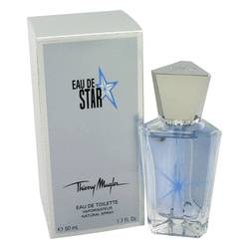

# 

***EAU DE STAR***

## *Description:*

Eau De Star by Thierry Mugler Perfume. Introduced in 2007 by Thierry Mugler, Eau De Star is an intriguing oriental fragrance made for women. This elixir features an exciting combination of notes, including floral notes of mimose, aquatic water notes, and sweet, juicy notes of honey and watermelon. The base notes enhance and compliment this young and fresh fragrance with patchouli and vanilla. Wear Eau De Star to school or on weekends for outings with friends to the mall or the movies.